**Research Question**

1. What are the variables that affect hotel reservation cancellations?
2. How can we make hotel reservation cancellations better?

**Hypothesis**

1. More cancellations occur when prices are higher.
2. Peoples are cancelled their booking when their booking room type does not match with assigned room type.
3. The majority of clients are coming from offline travel agents to make their reservations.

**Analysis and Findings**

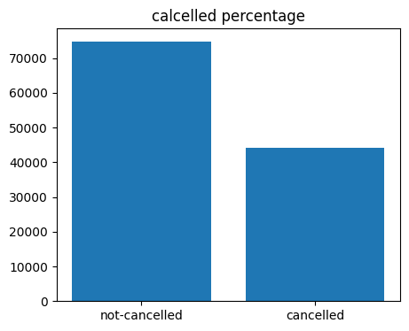

In above diagram, there are approx. 62% of clients who has not canceled their reservations but 37% of clients who canceled their reservations and it is very huge data, which has significant impact on hotel earnings.

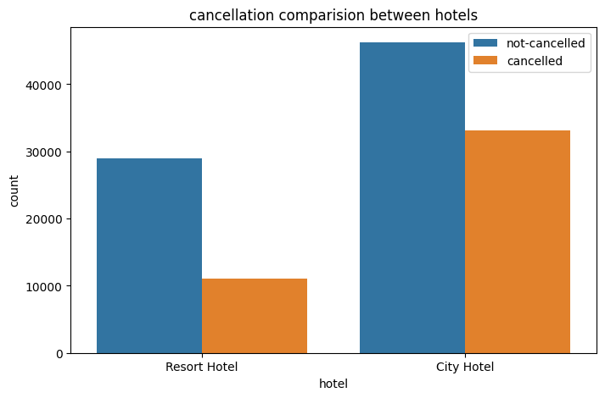

In comparison to resort hotels, city hotels have more bookings. It’s possibles that resort hotel are more expensive than city hotels.

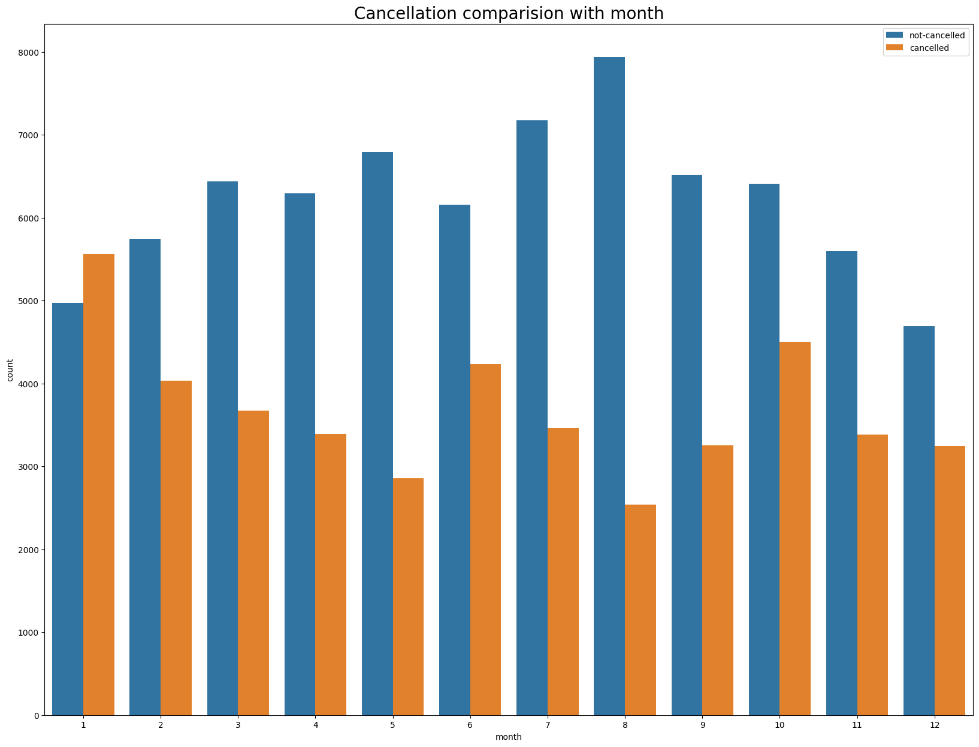

In this bar graph, we have developed reservation status comparison with month, as can be seen, confirmed reservation are high in the month of August. And cancelled reservation are low in the month of August. Whereas high cancellation rate in the month of January.

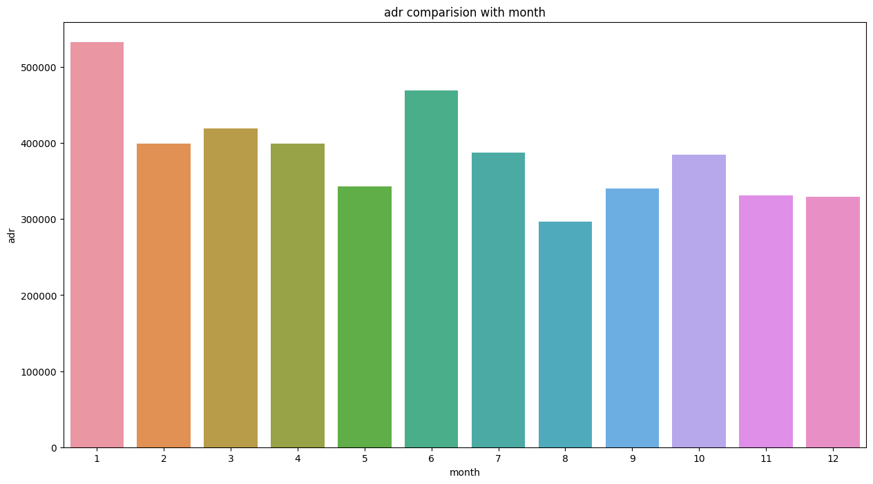

In this bar graph, As can we seen, The highest prices of hotels in the month of January and The lowest prices of hotels in the month of august And according to above graph, high cancellation rate in the month of January and lowest cancellation rate in the month of August thus we can say that, the cost of the hotel is responsible for the cancellations.

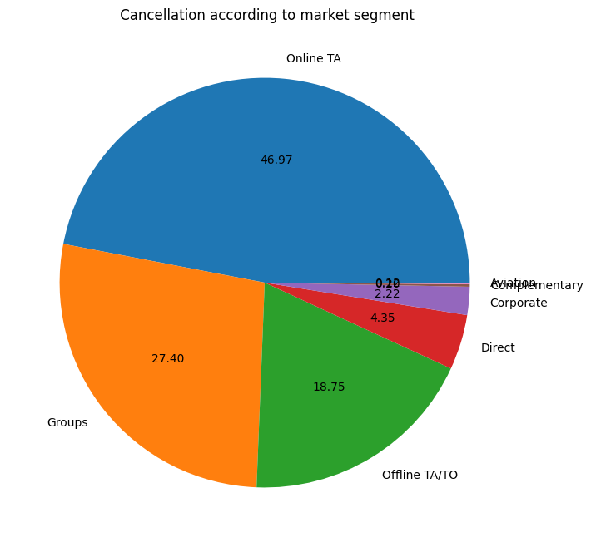

In above pie chart, we have developed Cancellation according to market segment and as can we seen, there are approx.. 46% cancellation in the online market segments and it is a very huge amount.

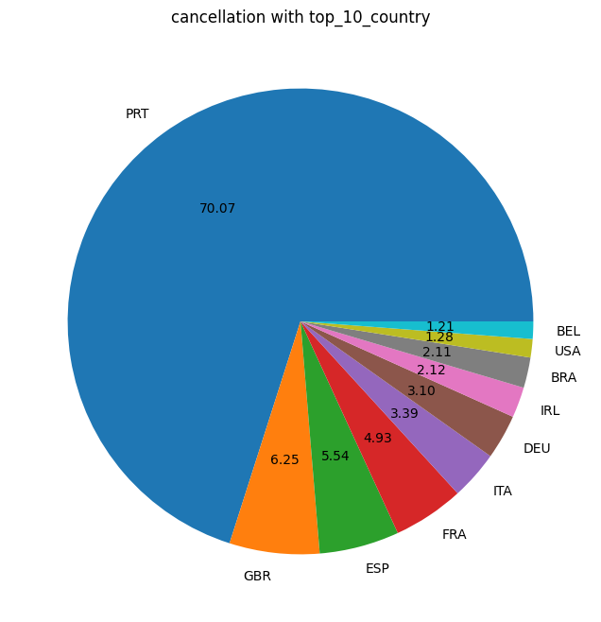

In this above pie chart, these are top 10 country where are more cancellation.

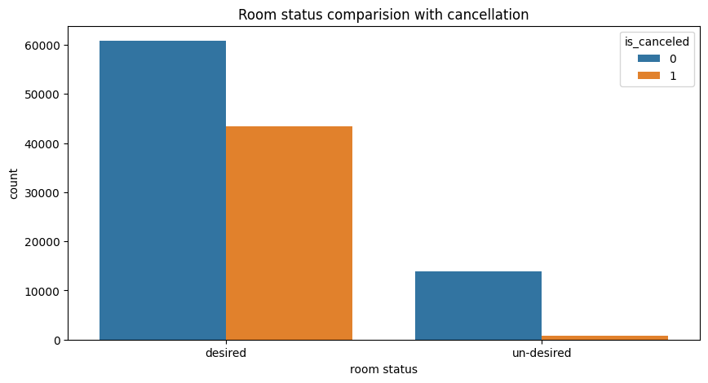

We assume that peoples are cancelled their reservation when their reservation room type does not match with assigned room type but It’s not true. As can we seen, highly cancellation in desired room status.

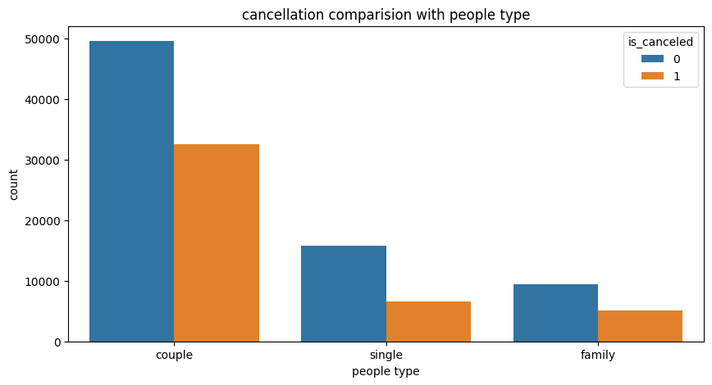

In above bar graph, As can we seen, couples are highly cancelled their reservation in comparison to others. And Most of the bookings are done by the couples and most of the cancellation are also done by them.

**Suggestions**

1. Prices are impact on the cancellation of the reservations so, hotels could work on their pricing strategies and try to lower rate for specific hotels and based on the locations. They can also provide some discounts to the consumers.
2. In the month of the January, hotels can start campaigns or marketing with the reasonable amount to increase their revenue because in the month of the January there are highest cancellation rate as compare to others.

3. Hotels should work on their Online TA of market segment and

provide some other discounts because there are high cancellation rate.

1. They can also increase the quality of the hotels and their services mainly in Portugal because there are high cancellation rate in the country of Portugal ‘PRT’.
2. Most of the bookings are done by the couples and most of the cancellation are also done by them so, hotels need to provide some other discount or facilities to the couples.